6. Implement Hierarchical Clustering
Aim:
To implement the Hierarchical Clustering algorithm using Python to group similar data points into clusters and visualize the clusters using a dendrogram.

Algorithm:
- Start the program.
- Import the required libraries, NumPy, Matplotlib, and Scikit-learn.
- Create a dataset containing input data points.
- Apply hierarchical clustering to the dataset.
- Calculate the distances between data points.
- Group similar data points into clusters.
- Display the cluster labels and visualize the clusters using a dendrogram.
- Stop the program.

CODE AND OUTPUT:

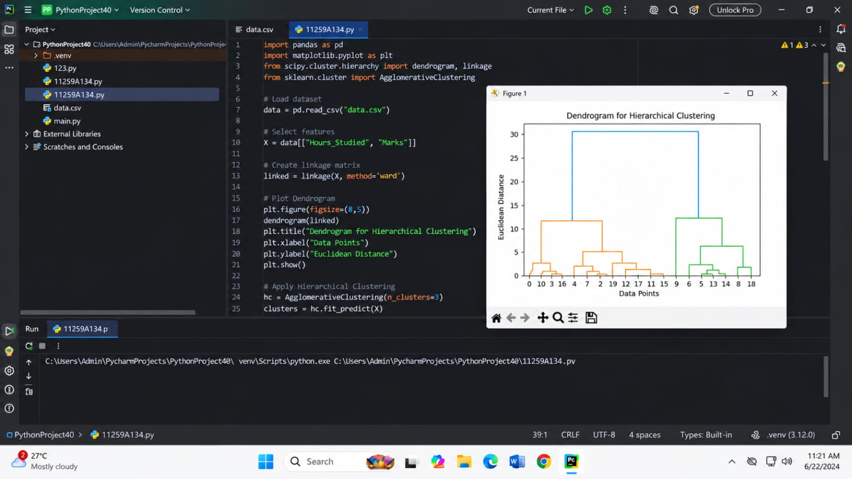
Result:
Thus, the Hierarchical Clustering algorithm was successfully implemented using Python, and similar data points were grouped into clusters.

